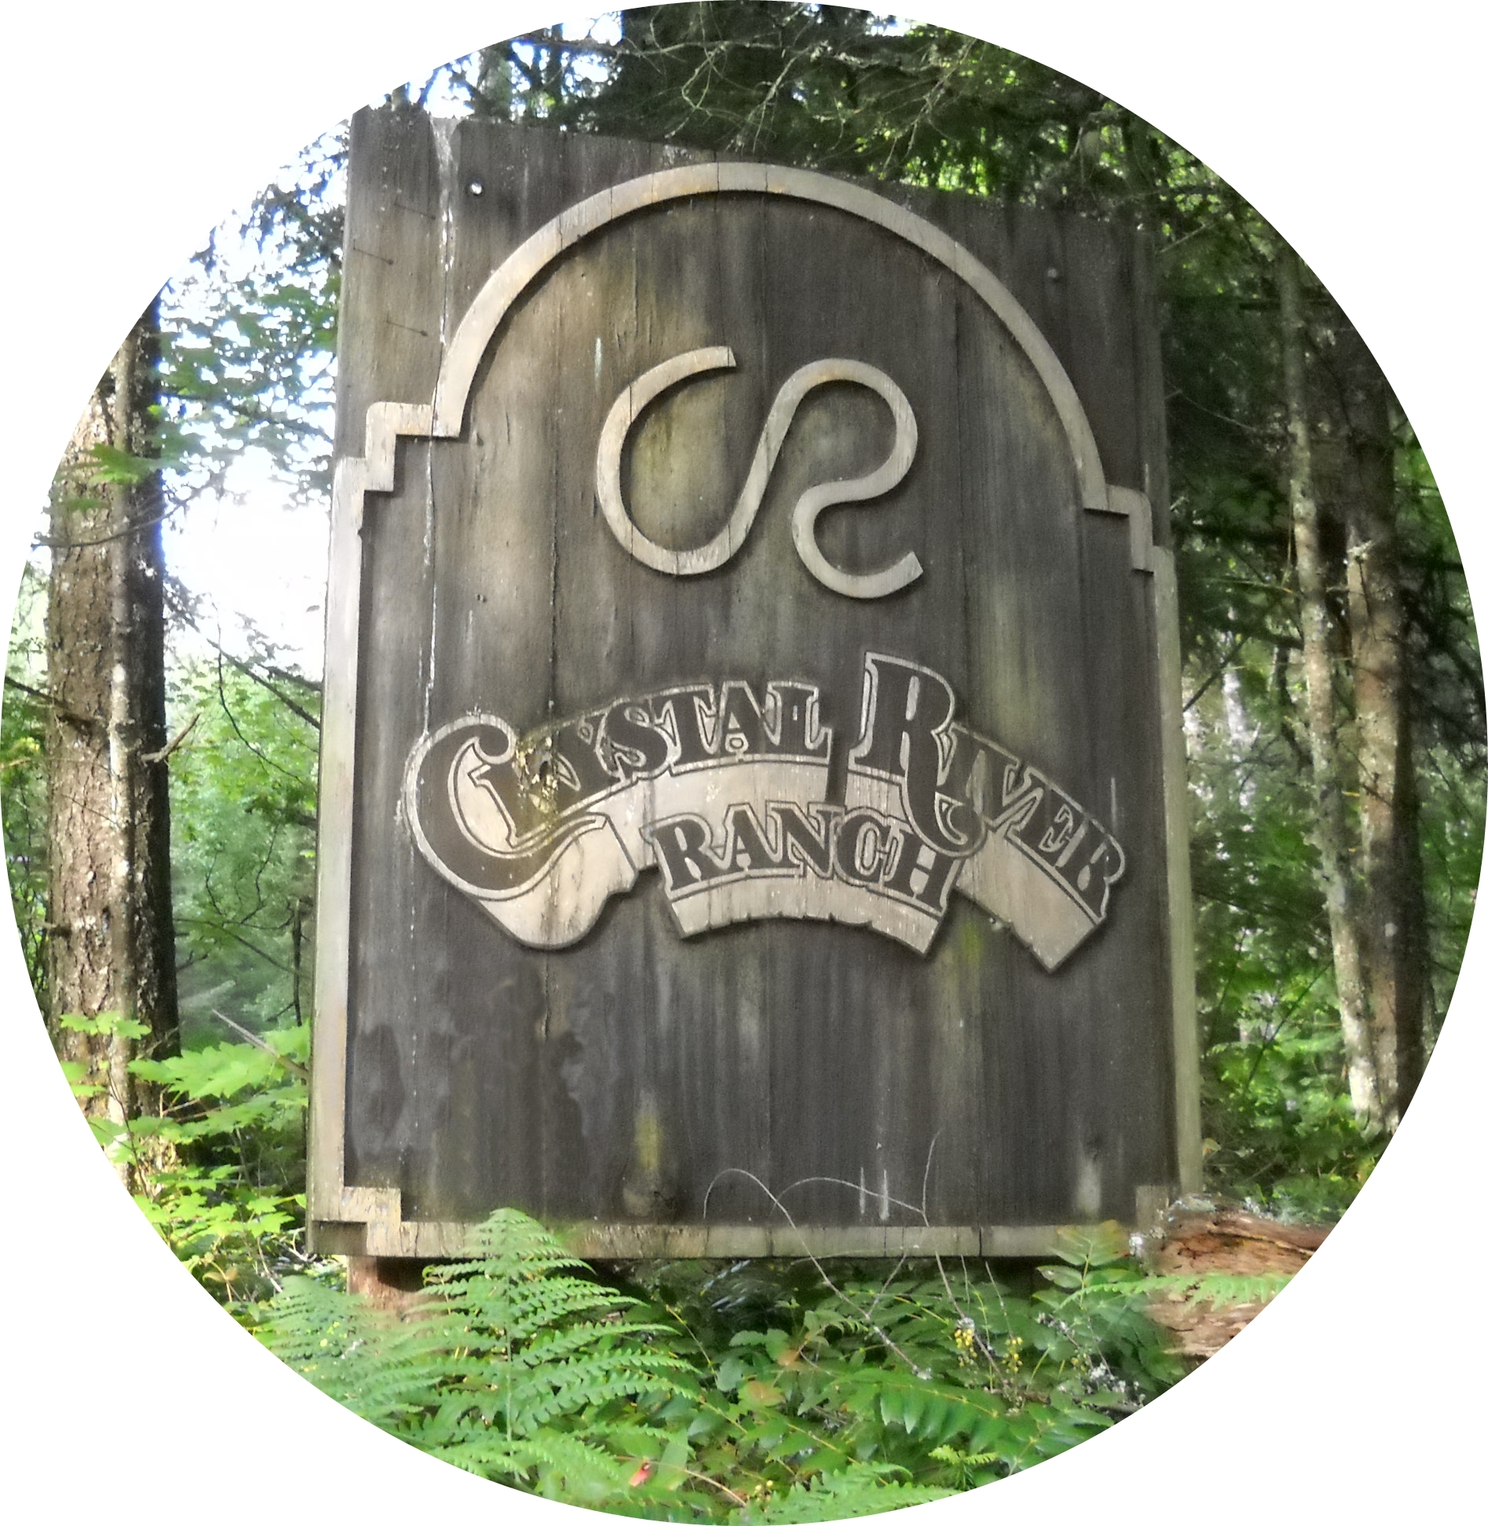
Crystal River Ranch Association
Email: crystalriverranch@gmail.com
Or Mail To: 62201 Meadow Way E, Greenwater, WA 98022

The Crystal River Ranch Association’s Board of Directors is looking for lot owners who are willing to volunteer their time to serve as board members for the next three years. The Board needs people who are interested in becoming involved in the operation of the association. As a representative of 240 lot owners, you would be a voice for your fellow community members.

There are 8 meetings throughout the year (the 3rd Saturday in January, March, April, May, July, September, October and November). If you are interested, please tell us about yourself, along with a brief description of why you would like to serve as a board member. Please return this form to the above address, or email to crystalriverranch@gmail.com by April 18th.

Thank you. Your community thanks you too!

_______________________________________________________________________________________________________________________________________________________________________________________________________________________________________________________________________________________________________________________________________________________________________________________________________________________________________________________________________________________________________________________________________________________________________________________________________________________________________________________________________________________________________________________________________________________________________________________________________________________________________________________________________________________________________________________________________________________________________________________________________________

Owner / Property Information
Name:
CRR Property Lot:
CRR Address

Annual assessments must be paid up to date to be a board member.

